**Crontab:**

Opening the Crontab to schedule the task:

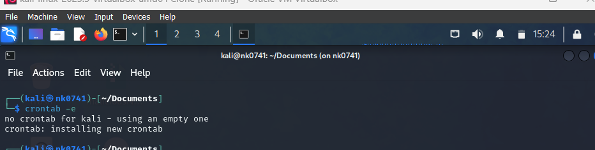

Adding the code for adding task to print “hello world nk0741” after 1min to the given file path

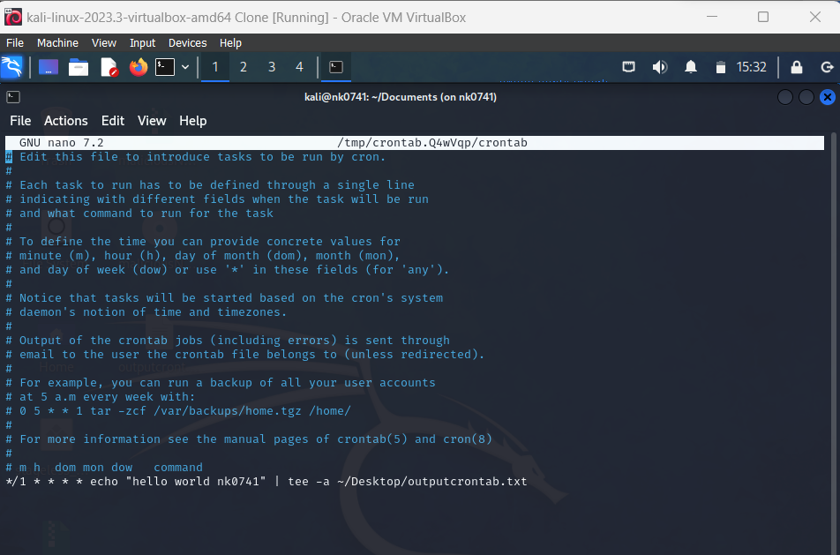

To list all the cron jobs.

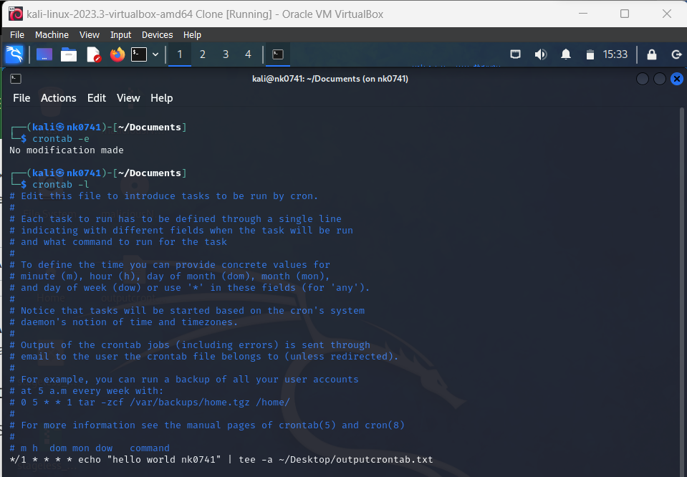

Before starting the task: The contents of the file:

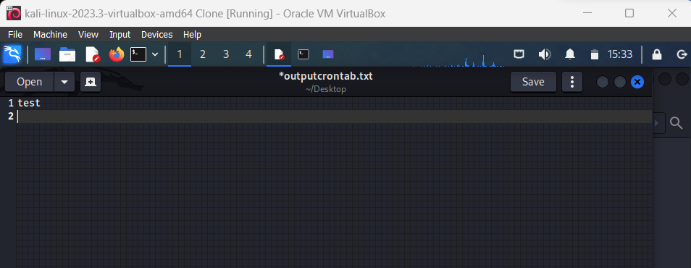

To start the cron job:

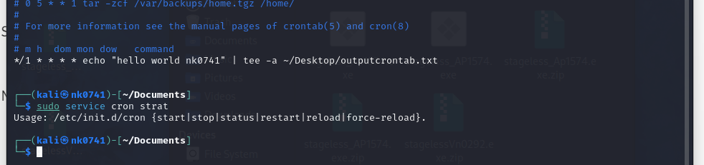

After 3mins:

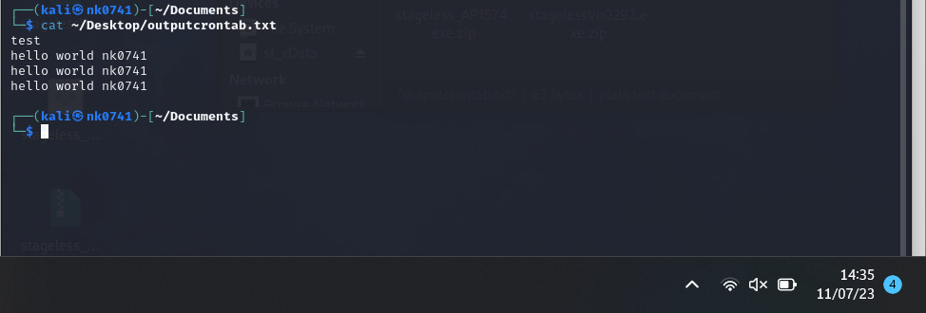

After 3 more mins:

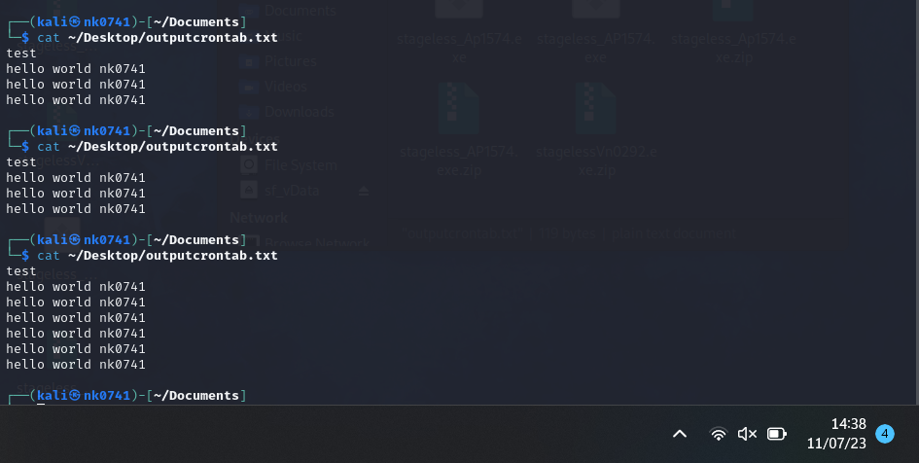

Stopping the cron task:

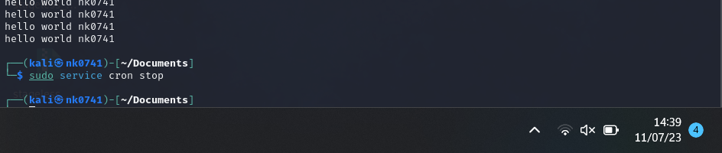

You can see from the below screenshot the file is not accessed after we stopped it.

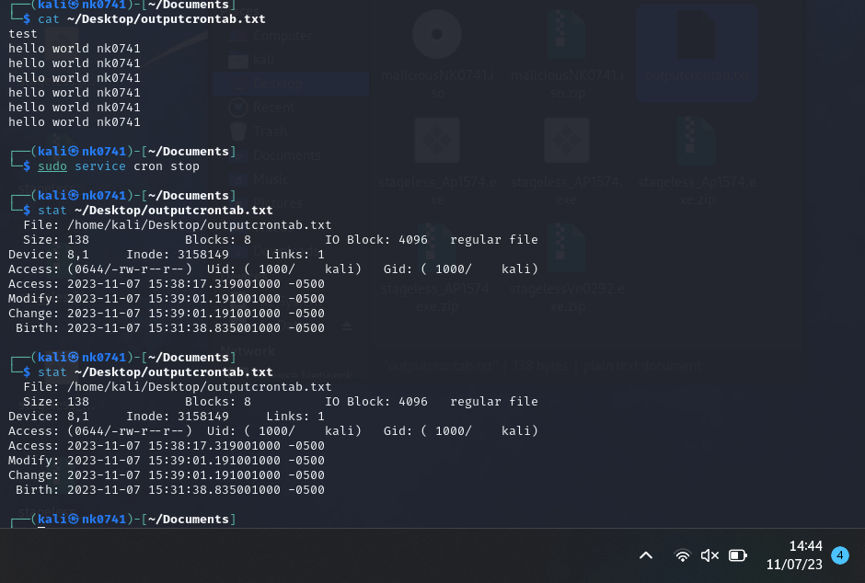

**Systemd:**

Created time.txt file using touch

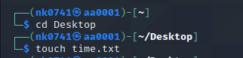

Created a write\_time.sh file

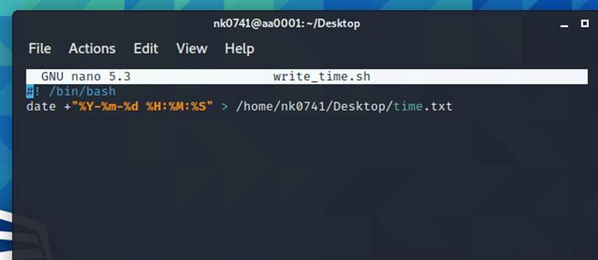

Created a service using the below command and entered the context. C:\Users\karas\AppData\Local\Packages\oice_16_974fa576_32c1d314_2216\AC\Temp\msohtmlclip1\01\clip_image004.png

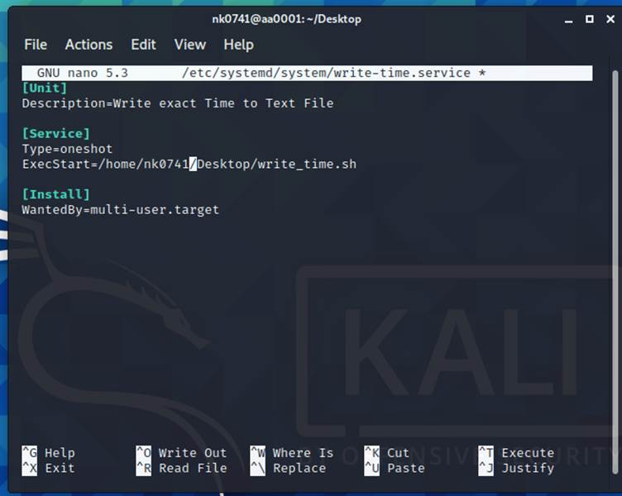

Created a timer file and written context. C:\Users\karas\AppData\Local\Packages\oice_16_974fa576_32c1d314_2216\AC\Temp\msohtmlclip1\01\clip_image007.png

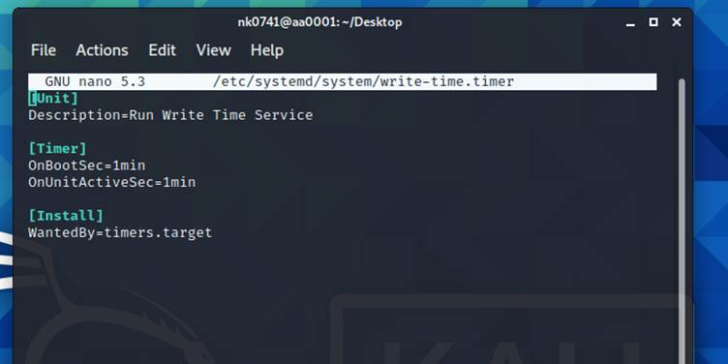

I have enabled the service by using below command. C:\Users\karas\AppData\Local\Packages\oice_16_974fa576_32c1d314_2216\AC\Temp\msohtmlclip1\01\clip_image010.png

I have started the service by using start command. 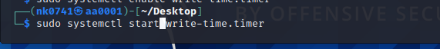

I have displayed the file which I have stored on desktop and it displays the time.

